**TTD PROCESS**

**Assignment 4: Test-Driven Development (TDD) Infographic**

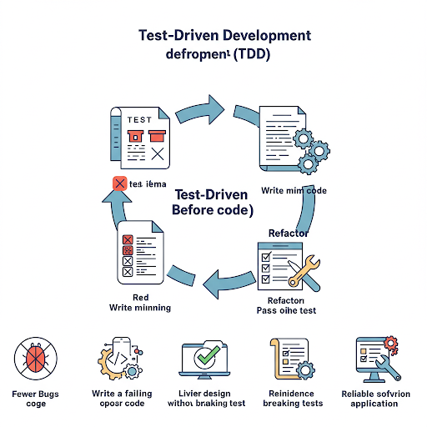

**Core Idea:** Write tests before code.

**Key Steps (Red-Green-Refactor):**

Red: Write a failing test.

Green: Write minimal code to pass the test.

Refactor: Improve code without breaking tests.

**Benefits:**

Fewer Bugs: Thinking about tests early catches issues.

Better Design: Code becomes more modular and testable.

Confidence: Tests ensure code works and prevent regressions.

Living Documentation: Tests show how the code should behave.

Reliable Software: Consistent testing leads to stable applications.

Infographic Visuals: Use a cyclical diagram showing the Red-Green-Refactor steps with icons. Illustrate benefits with short text and corresponding icons (e.g., a bug icon crossed out for "Fewer Bugs").